3 Stage Process for Deciding the Winner

Our Main Tool
The FIXED function tells tableau to do (count, sum average, etc…) something once for each field that is designated in the first part. E.g.
- {Fixed [Region],[Product] : Sum([Sales])}
This will return a total of sales for each product in each region.

Count Votes for Each Candidate
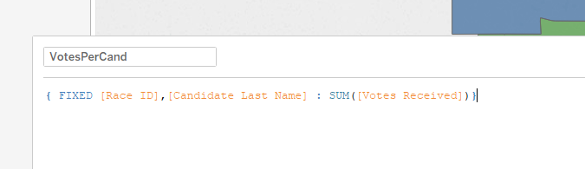
- What this says:
  - For each individual race, and each candidate, count the number of votes received and return that count as the answer.
- Why do we do it?
  - We can sum up the total votes received in a table easily, but this gives us a static value for that count that won’t be impacted by the scope.

Find the Maximum Number of Votes a Candidate Received
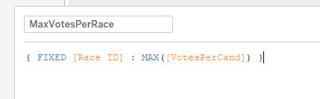
- What this says:
  - For each race find the maximum number of votes any person received (using the previous calculated field.
- Why do we do it?
  - We need to find the maximum this way rather than just using Max because we need to make sure that we separate out each race, while still summing each poling location.

Check if Each Candidate Won
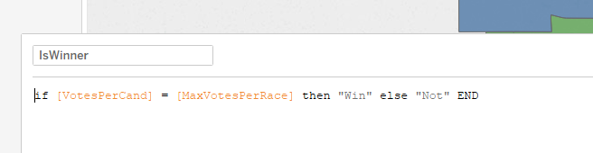
- What this says:
  - If the candidate we’re looking at has the most votes, label them the winner.
- Why do we do it?
  - Remember the way the data is formatted, we only have rows for candidate returns from each polling station. This adds a label of “Winner” to our winners.

